**National Park**

Developer’s Guide

Group Members:

|  |  |
| --- | --- |
| *Student ID* | *Student Name* |
| Student1605781 | Bilal Khan |
| Student1600865 | **MUHAMMAD ANUS UDDIN SHAIKH** |
| Student1600857 | Zohaib Khan |
| Student1600843 | Muhammad Raim |

Curriculum:

ACCP 7144 AI

Semester:

CPISM

Sir Farzan Ahmed

Faculty:

Certificate of Recognition

This certificate is proudly awarded to **National Park zoo** for its exceptional contribution to wildlife conservation, education, and the promotion of environmental stewardship.

The recognition of **National Park zoo** acknowledges its dedication to preserving endangered species, creating impactful educational programs, and fostering a greater appreciation for biodiversity among the community. The efforts made in the areas of animal care, conservation research, and public engagement are truly commendable.

This recognition serves as a testament to the hard work, commitment, and passion of the staff, management, and volunteers who contribute to the success and growth of the zoo, ensuring a better future for wildlife and a more informed public.

We celebrate **National Park zoo** **‘s** continued success in inspiring and educating future generations about the importance of protecting our natural world.

*31-Jan-2025*

Presented On:

*Sir Farzan Ahmed*

Faculty:

Acknowledgement

We would like to express our sincere gratitude to everyone who has contributed to the successful completion of this project. Our heartful thanks goes to **Sir Farzan** Khan for providing invaluable guidance and support throughout the whole process. We are deeply grateful to our colleagues and team members for their hard work, dedication, and collaboration. Their efforts have been instrumental bringing this project to fruition. We would also like to thanks our families for their love and support, which has allowed to stay focused and motivated. Finally, we extend our thanks to all those who has provided us with the resources and opportunities necessary to complete this project. This project would not have been possible without the help and support of all of you. THANK YOU.

Synopsis:

A **Zoo Park** is a facility designed to house and showcase a variety of animal species, providing an educational and recreational experience for the public. Its primary mission is to promote wildlife conservation, raise awareness about endangered species, and offer a safe environment for animals that may have been rescued, bred in captivity, or are part of ongoing species preservation efforts.

Zoo parks are carefully managed environments where visitors can observe a diverse range of animals in habitats that mimic their natural environments. These facilities aim to foster a deeper understanding of wildlife through educational programs, exhibits, and interactive activities. Many zoos also play a critical role in breeding programs for endangered species, as well as conducting scientific research on animal behavior, health, and genetics.

Zoo parks typically offer family-friendly experiences, with amenities like playgrounds, guided tours, and animal encounters, making them popular destinations for school trips, tourists, and wildlife enthusiasts. Additionally, they often host special events, workshops, and conservation efforts to engage the community in protecting wildlife and their habitats.

Overall, a zoo park serves as both an entertainment venue and a hub for conservation, educating the public while contributing to global efforts in wildlife protection and sustainability.

Distribution:

You can find the location of our shop in a very convenient way. You can also find our past experiences people narrative and the services we can provide you for your confirmation.

Problem Statement

**Web portal for National parks** is a website which provides the people who are interested in visiting national parks and interested in  wild animals can view this website to where they can get to know where the national park is situated and what all animals residing in that national park.

The existing system uses manual operations for Maintaining information of the national park and animals residing of that particular  park in paper and files which may be damaged due to externals causes like fire, water etc as a result it may lead to loss of information gathered permanently. And each national park may require a new record to store the information about that park which may also lead to so many records where finding it in set of national park records may be too difficult.

Existing system which was performed using manual operations overcomes by the proposed system called “National Parks” where viewing national parks and wild life in that particular park from anywhere in the world.

You are supposed to create a website for them with the below mentioned requirement specifications.

The website is to be developed for the Windows Platform using HTML5, JavaScript and Geolocation. The site should work well in all leading browsers including Chrome, IE, Firefox etc.

**Requirement Specification:**

The Web site is to be created based on the following requirements.

1. The Home Page should be created making use of Sections with a suitable logo, the header section can be added which will show images of animals.
2. The site must contain the links to navigate through any category for the information.
3. The site should display a menu which will contain the options for brief introduction about the various national parks available, location and any other information if required.
4. The web site should also provide the option of Animal Info in that particular national park page where viewers can get the information of well known animals and birds residing in that particular national park.
5. Also have a Site Map option where viewers can see what all National Parks are there in our web site and can easily know where it is situated in the country. Their location should be displayed using GeoLocation API (eg. GoogleMaps)
6. A brief summary of a particular national park including list of animals/birds available, other facilities at national park should be displayed on the Web Page along with the picture but detailed Features should be stored in Individual Word documents which can be downloaded or viewed by the User who wishes to see the same.

**Guide**

Navbar All pages:

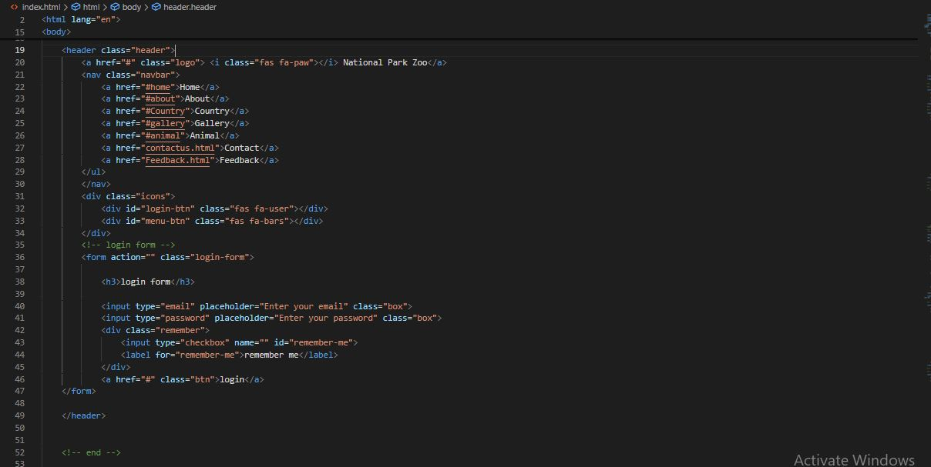

Home Gallery:

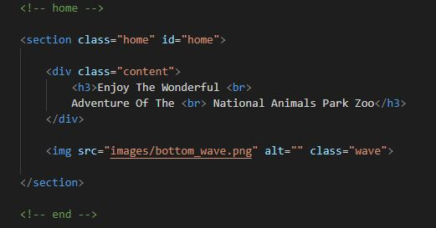

About Section:

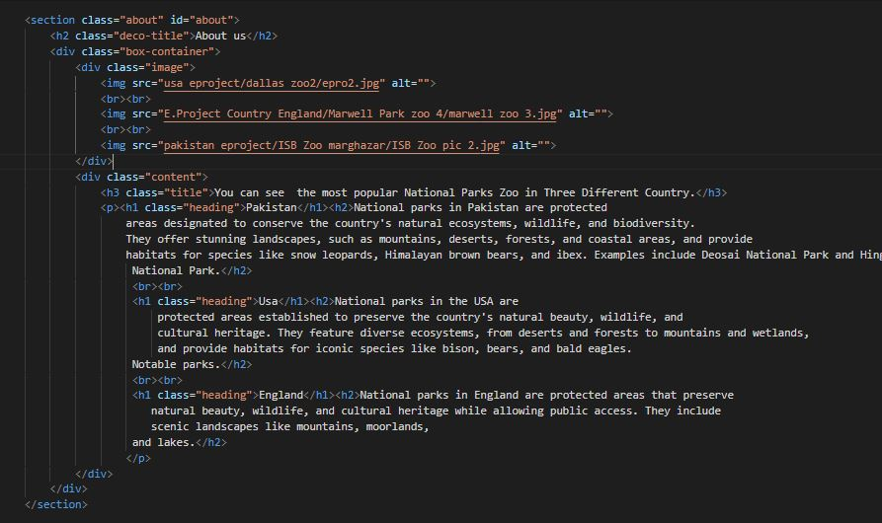

Country Parks Section:

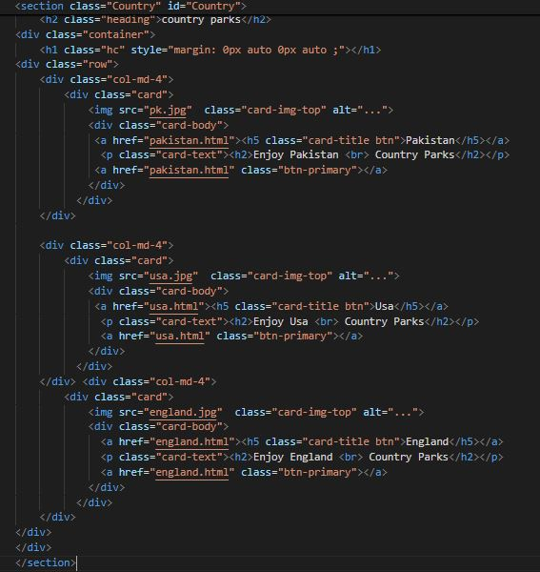

Gallery All Animals Section:

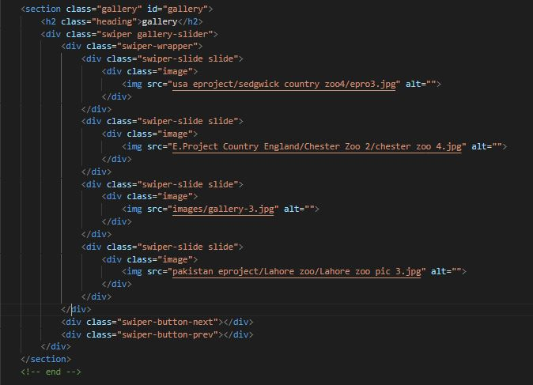

Animals Section:

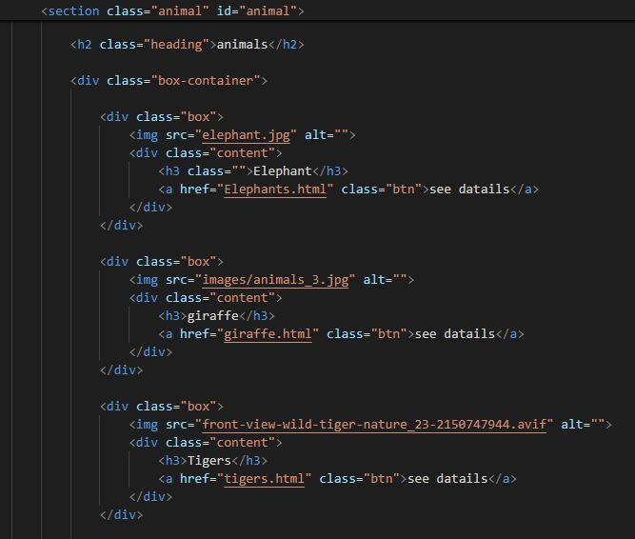

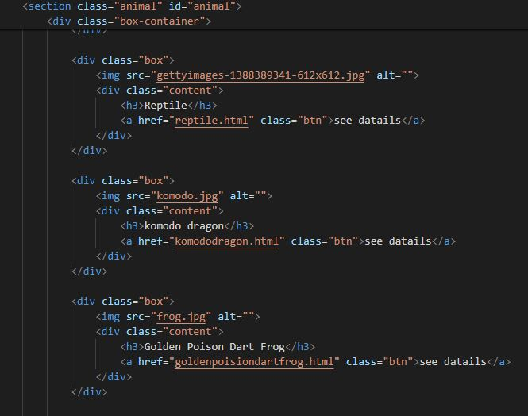

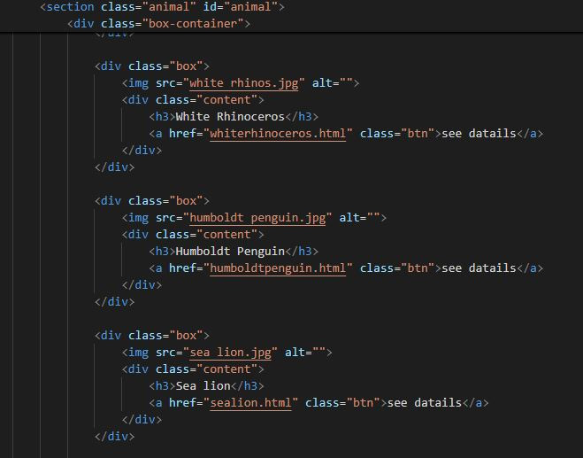

­­­

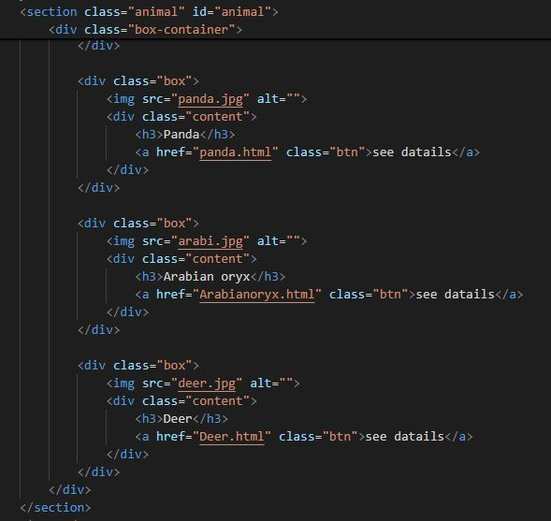

Country Parks detail:

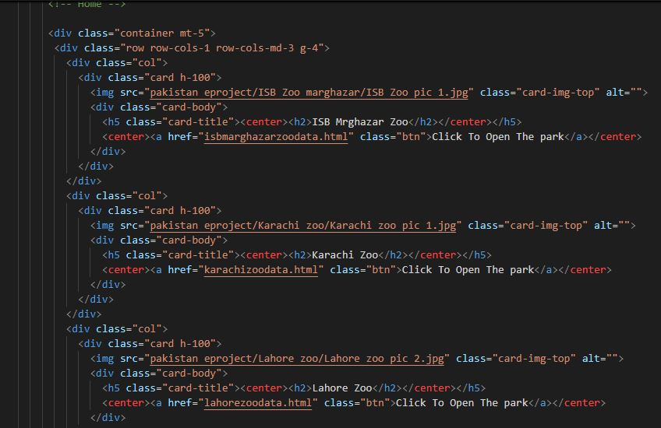

*All Country Parks Code are similar*

Parks detail:

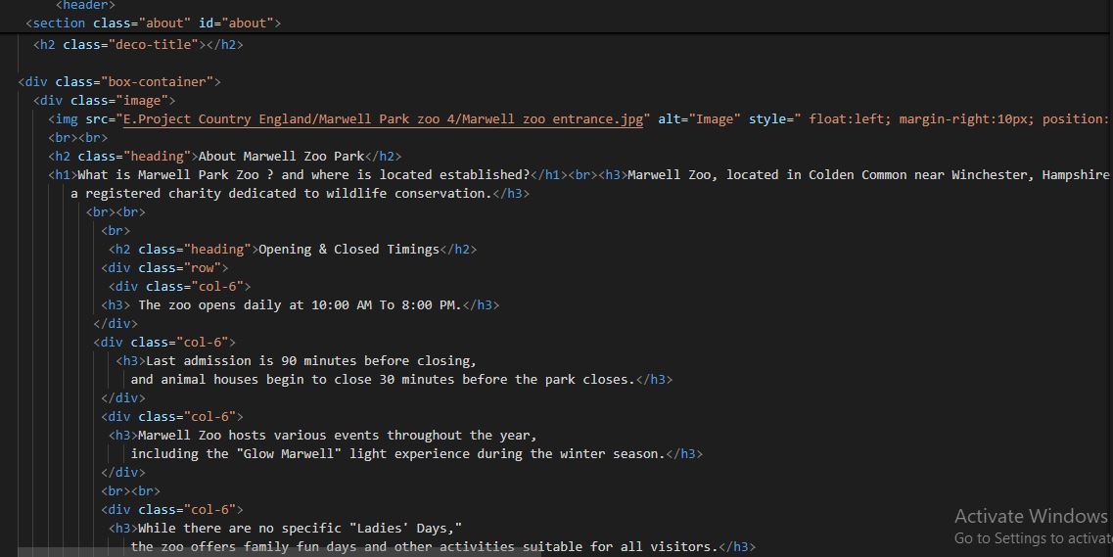

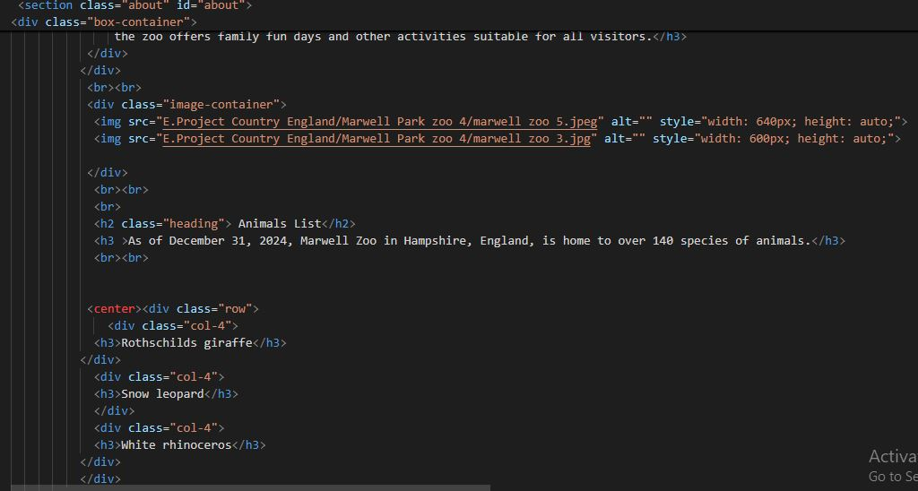

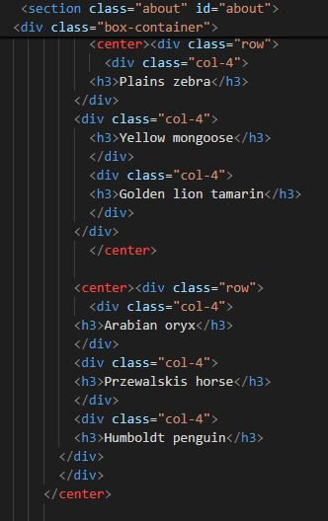

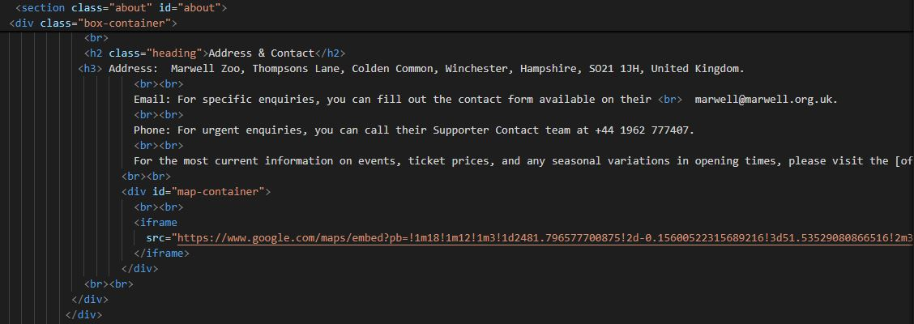

*All Parks Code are similar*

Map Section:

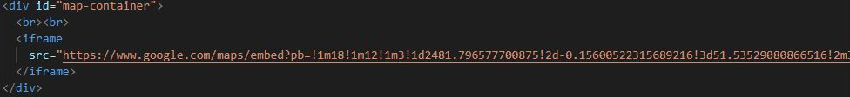

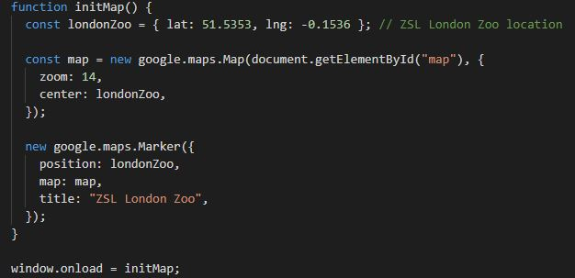

*All Parks Map Code are similar*